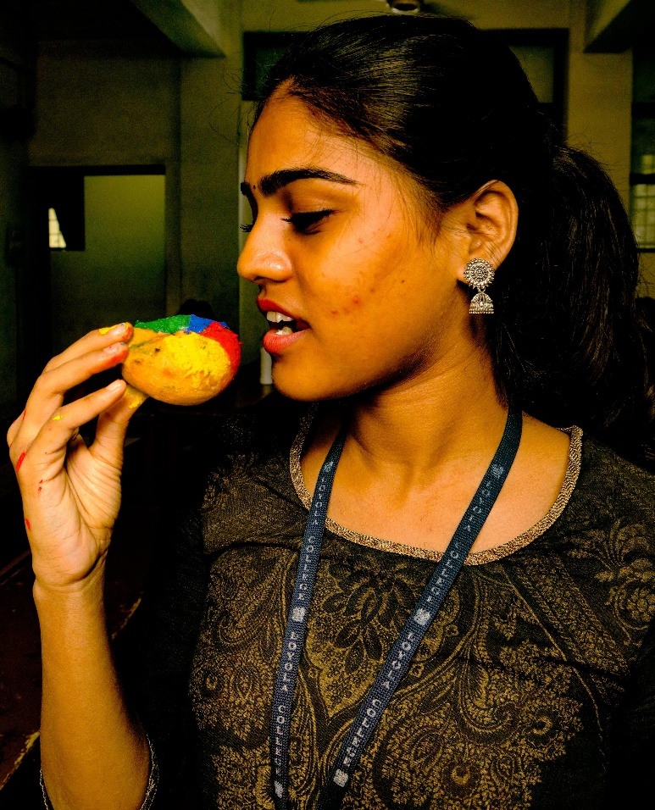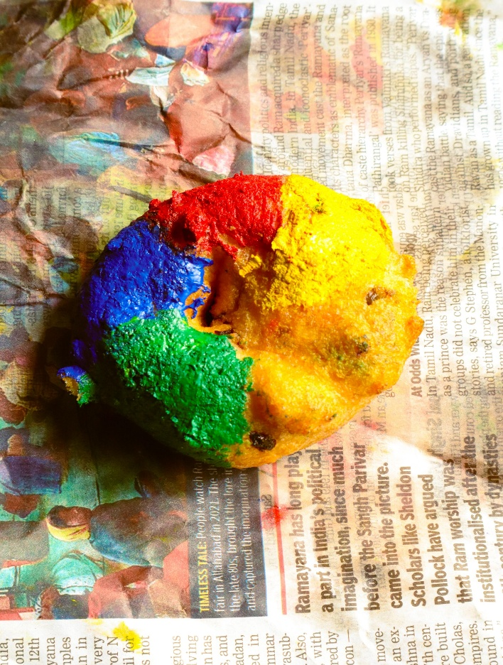**FROM PAGE TO PLATE, THE UNSEEN DANGERS OF ENJOYING OIL-FRIED SNACKS WRAPPED IN NEWSPAPERS**

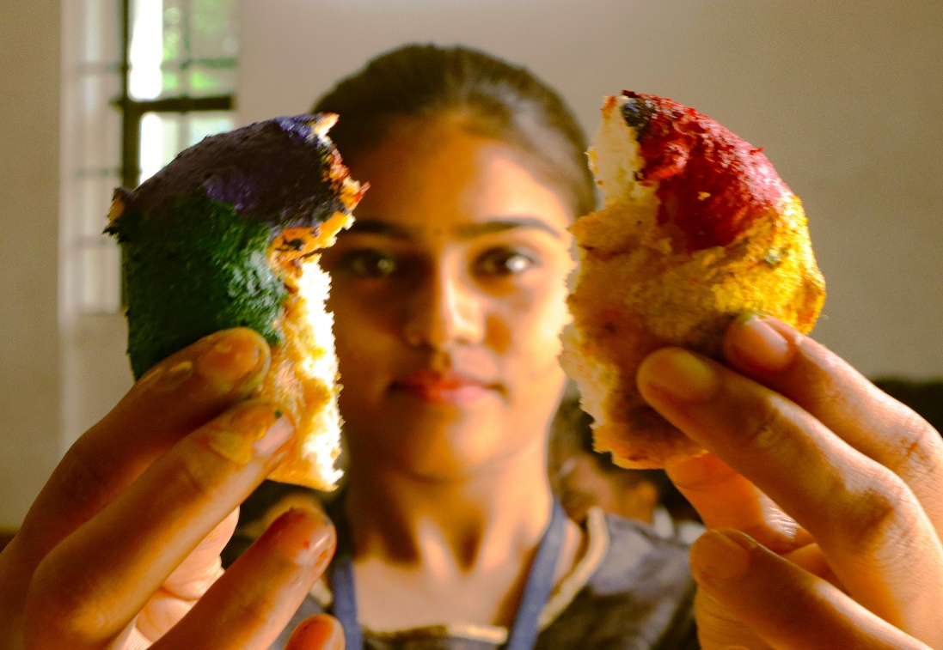

Despite the ban of wrapping food items in newspaper we have been persistently practising to serve oil-fried snacks wrapped in newspapers in India. According to the Food Safety and Standards (Packaging) Regulations, use of newspapers or similar materials for storing and wrapping food is strictly prohibited due to disturbing health repercussions which cause elevated risks. Printing inks contain harmful chemical contaminants which include volatile organic compounds (VOCs), predominantly used in industries and household applications. On the other hand, pathogenic micro organisms existence is observed in used newspapers. Oil-fried snacks like bajji, samosa and pakora are served in newspapers as they absorb the excess oil present in the food and also they are economically viable nonetheless, these oil-fried snacks absorb the potential dangers present in the newspaper as well. That being the case, not only are we ingesting the food, but also the chemicals and micro organisms present in the newspaper. One of the reasons why we have been refused to pay attention to this matter is because multitude of underprivileged people in urban cities sell newspaper envelopes for a living, called “thonga”. Matter of fact, used newspapers have economic value as thongas resale these used newspaper envelopes to hawker stalls in india and it is said that banning of used newspapers for the purpose of serving food might adversely affect them. Yet this cannot be reckoned as dispensation since ingesting such hazardous elements likely can wreck our health hence we are advised to replace newspapers with tissues and banana leaves.